Success5:

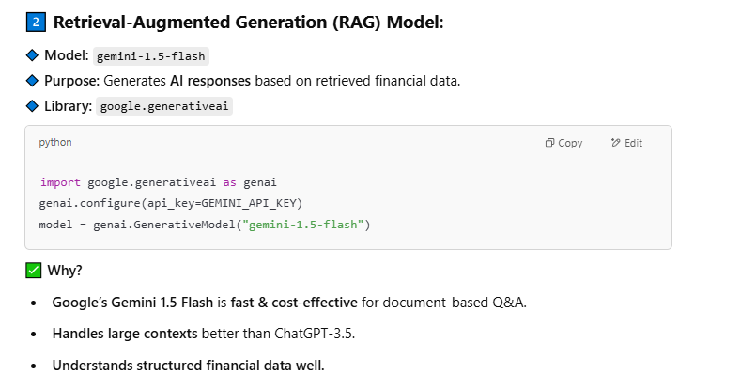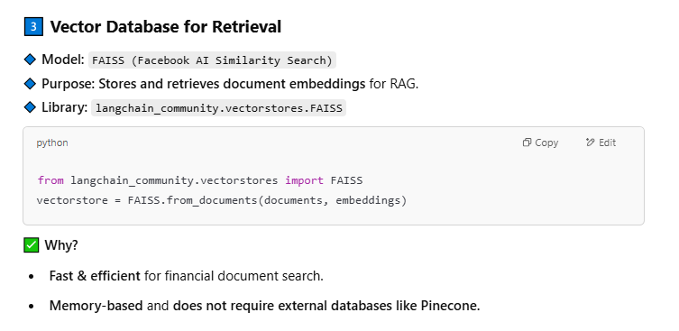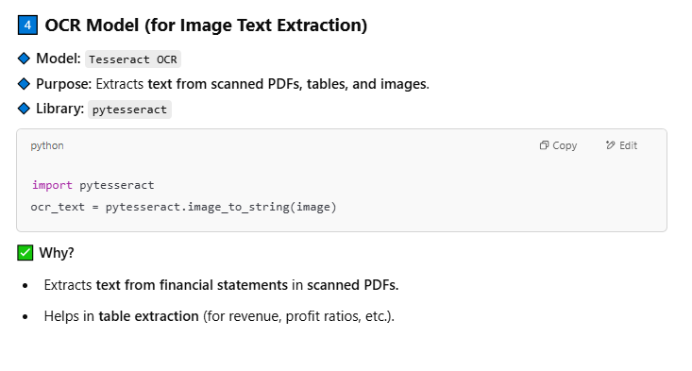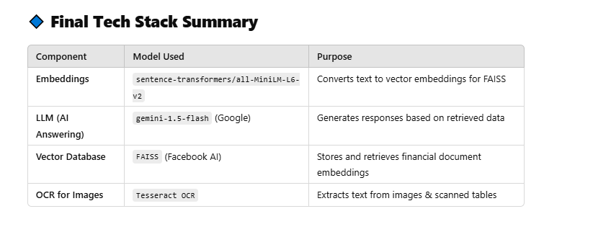

Success9 results:

which are the top 5 important paramters of any stock and what should be their range to invest in thta particular stock?

**🤖 Groq (LLaMA 3)**

While there are numerous parameters to analyze a stock, here are the top 5 important ones to consider, along with general guidelines on their ideal ranges:

**1. Price-to-Earnings (P/E) Ratio**

* Ideal Range: 15-25 (varies by industry and market conditions)
* Why: The P/E ratio indicates how much investors are willing to pay per dollar of earnings. A lower P/E ratio may indicate undervaluation, while a higher ratio may suggest overvaluation.

**2. Debt-to-Equity (D/E) Ratio**

* Ideal Range: 0.5-1.5 (varies by industry and company size)
* Why: The D/E ratio measures a company's leverage. A lower ratio indicates a healthier balance sheet, while a higher ratio may suggest higher risk and potential debt issues.

**3. Return on Equity (ROE)**

* Ideal Range: 15%-25% (varies by industry and company size)
* Why: ROE measures a company's profitability from shareholders' perspective. A higher ROE indicates efficient use of equity, while a lower ROE may suggest poor capital allocation.

**4. Dividend Yield**

* Ideal Range: 2%-5% (varies by industry and market conditions)
* Why: Dividend yield represents the annual dividend payment as a percentage of the stock's current price. A higher dividend yield may indicate a relatively undervalued stock, while a lower yield may suggest overvaluation.

**5. Earnings Per Share (EPS) Growth Rate**

* Ideal Range: 10%-20% (varies by industry and company size)
* Why: EPS growth rate measures a company's ability to increase its profitability. A higher EPS growth rate may indicate a strong, growing company, while a lower growth rate may suggest sluggishness.

Please note that these are general guidelines, and the ideal ranges may vary depending on:

1. Industry norms: Different industries have different benchmarks for these parameters.
2. Company size: Larger companies may have different benchmarks than smaller ones.
3. Market conditions: Economic downturns or periods of high growth may affect the ideal ranges.
4. Investment goals: Conservative investors may prioritize lower risk, while growth investors may target higher returns.

It's essential to consider these parameters in conjunction with others, such as revenue growth, profit margins, and cash flow, to form a comprehensive picture of a stock's investment potential. Additionally, always conduct thorough research and consider your own risk tolerance, investment goals, and time horizon before investing in any stock.

**🔍 Gemini (Google)**

There's no single "perfect" range for any stock parameter that guarantees investment success. The ideal values depend heavily on the specific company, its industry, its growth stage, and the overall market conditions. However, here are five important parameters to consider, along with general guidelines – remember these are guidelines, not strict rules:

1. **Price-to-Earnings Ratio (P/E):** This shows how much investors are willing to pay for each dollar of a company's earnings.
   * **General Guideline:** A P/E ratio below the market average *might* indicate undervaluation, while a ratio significantly above the average *might* suggest overvaluation. However, high-growth companies often have higher P/E ratios. There's no magic number. Compare the P/E to industry averages and the company's historical P/E.
2. **Price-to-Book Ratio (P/B):** This compares a company's market price to its book value (assets minus liabilities).
   * **General Guideline:** A P/B ratio below 1 could indicate undervaluation, suggesting the market is valuing the company below its net asset value. However, this isn't always the case, as intangible assets (brand recognition, intellectual property) aren't fully reflected in book value. Again, compare to industry averages.
3. **Debt-to-Equity Ratio:** This shows the proportion of a company's financing that comes from debt versus equity.
   * **General Guideline:** A lower ratio (e.g., below 1) generally indicates less financial risk. High debt can make a company vulnerable during economic downturns. However, some industries naturally use more debt than others. Analyze the ratio in context.
4. **Return on Equity (ROE):** This measures how efficiently a company uses shareholder investments to generate profits.
   * **General Guideline:** A higher ROE (e.g., above 15%) typically suggests better management and profitability. However, compare this to industry benchmarks and consider the company's growth rate. A temporarily high ROE might not be sustainable.
5. **Revenue Growth:** This shows the percentage increase in a company's revenue over time.
   * **General Guideline:** Consistent revenue growth is a positive sign of a healthy business. The ideal growth rate depends on the industry and the company's life cycle. Rapid growth is desirable but also needs to be sustainable. Look at multiple years of data, not just a single year.

**Crucial Considerations:**

* **Industry context:** Compare these ratios to competitors within the same industry. A high P/E ratio might be normal for a tech company but alarming for a utility company.
* **Company specifics:** Analyze the company's financial statements thoroughly, understand its business model, and consider its future prospects. Don't rely solely on these five metrics.
* **Qualitative factors:** Consider factors beyond numbers, such as management quality, competitive landscape, and regulatory environment.
* **Risk tolerance:** Your investment decisions should align with your own risk tolerance.

**Disclaimer:** I am an AI chatbot and cannot provide financial advice. The information above is for educational purposes only. Consult with a qualified financial advisor before making any investment decisions.

Success10 response:

top 5 stock parameters and their range inorder to decide whether to invest in that stock or not

**🤖 Groq (LLaMA 3)**

When considering whether to invest in a stock, it's essential to evaluate various parameters that reflect its fundamental and technical performance. Here are the top 5 stock parameters and their ranges to help you make a more informed decision:

1. **Price-to-Earnings (P/E) Ratio**:
   * Range: 10-30
   * Lower is better: A lower P/E ratio indicates that the stock is relatively cheap compared to its earnings performance.
2. **Return on Equity (ROE)**:
   * Range: 15-30%
   * Higher is better: A higher ROE indicates that the company is generating strong profits from its equity.
3. **Dividend Yield**:
   * Range: 2-6%
   * Higher is better: A higher dividend yield suggests that the company is distributing a significant portion of its profits to shareholders.
4. **Revenue Growth Rate**:
   * Range: 5-20%
   * Higher is better: A higher revenue growth rate indicates that the company is expanding its business and increasing its earnings potential.
5. **Debt-to-Equity Ratio**:
   * Range: 0.2-1.0
   * Lower is better: A lower debt-to-equity ratio indicates that the company has a healthier balance sheet with more equity financing.

When evaluating these parameters, consider the following:

* Industry benchmarks: Compare the stock's parameters to its industry peers to ensure it's relatively strong.
* Historical performance: Look at the stock's historical performance to identify trends and patterns.
* Future prospects: Analyze the stock's future prospects, such as its growth potential, management team, and competitive advantage.

If a stock exhibits strong performance in multiple parameters, it may be a good candidate for investment. For example:

* P/E ratio: 15-20
* ROE: 20-25%
* Dividend Yield: 4-5%
* Revenue Growth Rate: 10-15%
* Debt-to-Equity Ratio: 0.3-0.5

However, it's essential to remember that these parameters are only a starting point. Conduct thorough research, consult with financial advisors, and consider other factors before making an investment decision.

**🔍 Gemini (Google)**

There's no single "top 5" and universal range for stock parameters to guarantee investment success. The optimal parameters and their acceptable ranges depend heavily on your investment strategy, risk tolerance, investment horizon, and the specific sector the stock belongs to. However, here are 5 commonly analyzed parameters and general considerations regarding their values, understanding that these are *guidelines* and not hard rules:

**1. Price-to-Earnings Ratio (P/E Ratio):**

* **What it is:** The ratio of a company's stock price to its earnings per share (EPS). It indicates how much investors are willing to pay for each dollar of a company's earnings.
* **General Considerations:** A lower P/E ratio might suggest undervaluation, while a higher one might indicate overvaluation. However, the "acceptable" range varies widely by industry. Growth stocks often have higher P/E ratios than value stocks. Comparing a company's P/E to its industry average is more informative than looking at it in isolation. A P/E of 0 or negative might indicate a loss-making company.
* **Range (Illustrative, not definitive):** No single "good" range. Could range from single digits (value stocks) to several dozen (growth stocks). Context and comparisons are crucial.

**2. Price-to-Book Ratio (P/B Ratio):**

* **What it is:** The ratio of a company's market capitalization to its book value (assets minus liabilities). It indicates how much investors are willing to pay for each dollar of a company's net assets.
* **General Considerations:** A lower P/B ratio might suggest undervaluation, but a very low P/B might signal underlying problems. Again, industry context is crucial. This ratio is more relevant for companies with significant tangible assets.
* **Range (Illustrative, not definitive):** Can range from below 1 to several times the book value, depending on the industry and growth prospects.

**3. Debt-to-Equity Ratio:**

* **What it is:** The ratio of a company's total debt to its total equity. It measures the company's financial leverage.
* **General Considerations:** A high debt-to-equity ratio indicates the company relies heavily on debt financing, which can be risky if interest rates rise or revenues decline. A lower ratio suggests greater financial stability.
* **Range (Illustrative, not definitive):** Generally, a ratio below 1 is considered acceptable, but the ideal range varies across industries. Highly capital-intensive industries might have higher ratios than others.

**4. Return on Equity (ROE):**

* **What it is:** A measure of how efficiently a company uses its shareholders' investments to generate profits.
* **General Considerations:** A higher ROE generally indicates better management and profitability. Comparing the ROE to industry averages and trends over time is important.
* **Range (Illustrative, not definitive):** A good ROE is generally considered to be above 15%, but this varies significantly by industry.

**5. Revenue Growth:**

* **What it is:** The percentage increase in a company's revenue over a given period (e.g., year-over-year).
* **General Considerations:** Consistent revenue growth is a sign of a healthy and expanding business. Look for sustainable growth, not just short-term spikes.
* **Range (Illustrative, not definitive):** A desirable rate depends on the company's stage of development and industry. High single-digit to double-digit growth is often considered positive, but this is highly industry-specific.

**Crucial Disclaimer:** Using these parameters alone is insufficient for making informed investment decisions. Thorough due diligence, including understanding the company's business model, competitive landscape, management team, and overall economic environment, is essential. Consult with a financial advisor before making any investment decisions. Past performance is not indicative of future results.

**Question 2: financial ratios dicussed in the book**

**🤖 Groq (LLaMA 3)**

**The book is discussing financial ratio analysis, specifically Chapter 9, "The Financial Ratio Analysis (Part 1)", which will cover important financial ratios. Here are some potential financial ratios that might be discussed in the book:**

1. **Liquidity Ratios:**
   * **Current Ratio: Current Assets / Current Liabilities**
   * **Quick Ratio (Acid-Test Ratio): (Current Assets - Inventory) / Current Liabilities**
   * **Cash Ratio: Cash and Cash Equivalents / Current Liabilities**
2. **Profitability Ratios:**
   * **Gross Profit Margin: (Gross Profit / Revenue) x 100%**
   * **Operating Profit Margin: (Operating Profit / Revenue) x 100%**
   * **Net Profit Margin: (Net Profit / Revenue) x 100%**
   * **Return on Equity (ROE): Net Profit / Total Shareholders' Equity**
   * **Return on Assets (ROA): Net Profit / Total Assets**
3. **Efficiency Ratios:**
   * **Asset Turnover Ratio: Revenue / Total Assets**
   * **Revenue Growth Rate: (Current Revenue - Previous Revenue) / Previous Revenue**
4. **Solvency Ratios:**
   * **Debt-to-Equity Ratio: Total Debt / Total Shareholders' Equity**
   * **Interest Coverage Ratio: Earnings Before Interest and Taxes (EBIT) / Interest Expenses**
5. **Cash Flow Ratios:**
   * **Cash Flow Margin: (Cash Flow from Operations / Revenue) x 100%**
   * **Cash Conversion Cycle: Days Inventory Outstanding (DIO) + Days Sales Outstanding (DSO) - Days Payable Outstanding (DPO)**

**These are just some examples of financial ratios that might be discussed in the book. The actual ratios covered will depend on the book's focus and scope.**

**🔍 Gemini (Google)**

**The provided text snippets indicate that the book discusses financial ratios extensively, particularly within a module dedicated to fundamental analysis. While the exact ratios aren't listed, the emphasis is clear: the book uses financial ratios as a key method for analyzing financial statements. The mention of Benjamin Graham suggests a focus on fundamental analysis techniques popularized by him, likely including commonly used ratios such as profitability, liquidity, solvency, and efficiency ratios.**